# Exercise: Exception Handling

This document defines an in-class exercise from the ["OOP" Course @ Software University](https://softuni.bg/courses/oop/).

## Valid Person

Define a simple class Person which has the following fields: **first name**, **last name** and **age**. **Validate** the data in the properties’ setters, **throw** appropriate **exceptions** in case invalid data is entered.

### Step 1. Create a Class Person

Create a project for this exercise and add a class Person in a separate .cs file. The class should contain the following fields: **first name (string), last name (string) and age (int)**.

All fields are **required**, meaning you should have one constructor accepting all three as parameters. For example:

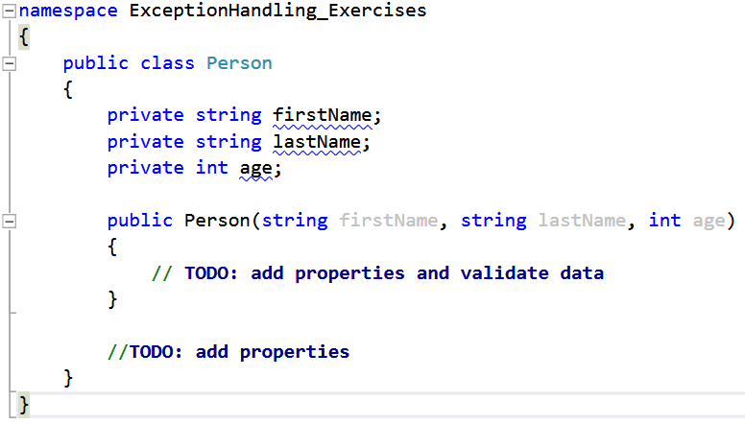

### Step 2. Add Properties and Validate the Data

Add a property for each of the fields. Perform validations in their **setters** to keep the state of the Person objects correct.

The **first** and **last name** cannot be **null** or **empty** strings. To check this, use the **string.IsNullOrEmpty()** method.

The **age** must be in the range **[0 … 120]**.

If invalid data is entered, **throw** appropriate exeptions with descriptive **messages**. E.g., if an empty name is entered, an appropriate exception may be **ArgumentNullException**. If the age is negative or too big, an appropriate exception would be **ArgumentOutOfRangeException**.

Example for validating the **first name** (last name is analagous):

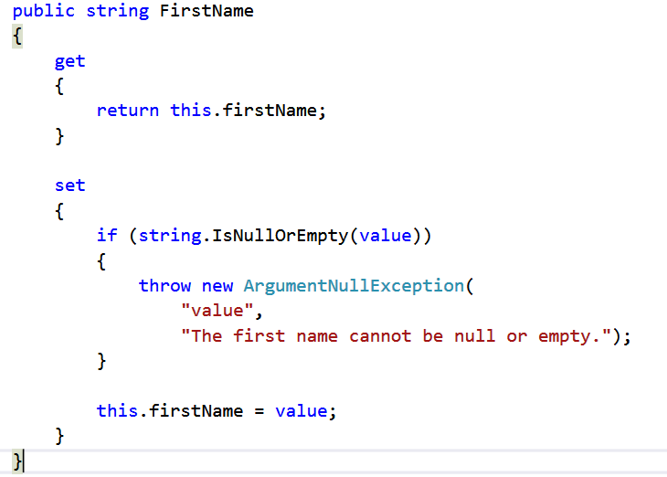

Example for validating the **age**:

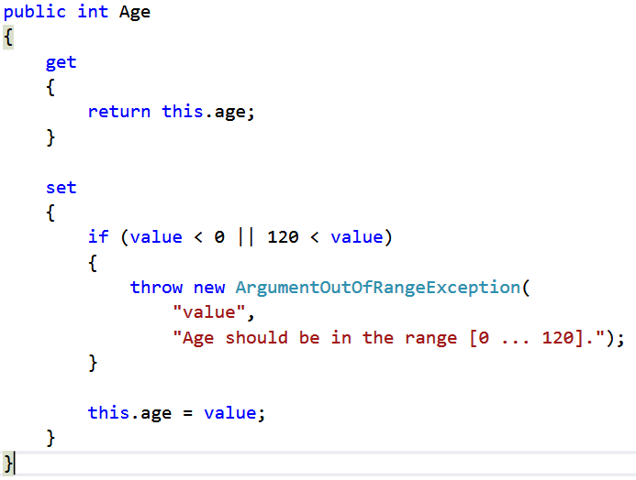

Now the constructor should make use of the properties instead of modifying the private fields directly:

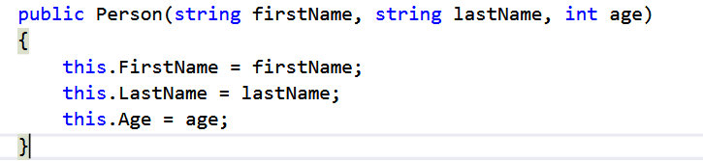

### Step 3. Test the Person Class

In your main program, test whether your class behaves properly. Create several objects of type Person – one with **valid data**, one with **empty first name**, one with **null as last name**, one with **negative age** and one **with age > 120**. Check whether executing the code results in errors when bad data is provided. Test the invalid cases one by one by commenting out the other invalid lines of code (your program will stop executing when the first error is encountered).

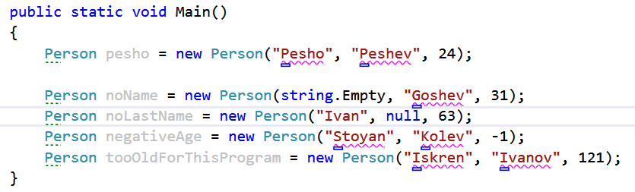

### Step 4. Add Try-Catch Blocks

To prevent the program from blowing up, surround the invalid lines in **try-catch** blocks. It’s a good practice to put different catch blocks for the different types of errors you anticipate the operation might throw. Print the **message** of the exception in the catch block.

Example (invalid **name**):

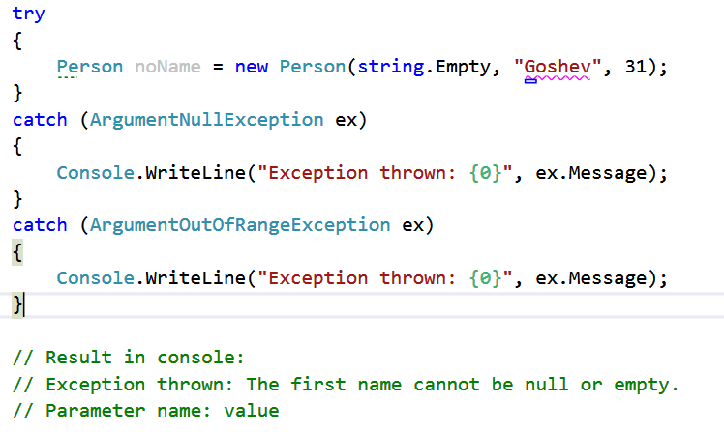

Example (invalid **age**):

